Shift, Store, or Sell:

Analyzing Scheduling Freedom in Smart Homes

By

YE XU

WEI LI

ZHEFAN LIN

XI ZHANG

**ABSTRACT**

**Keywords**

Renewable energy, scheduling, home house, GreenSwitch

# Introduction

The cost of electricity is increasing. In the past 25 years, the price of residential electricity has increased about 30%. [1] With more appliance used in resident home, the demand of electricity has increased almost 50% over 20 years. [2] According to the US Department of Energy (DOE), buildings accounted for about 38.9% of US primary energy consumption in 2006, 74% of which is electrical energy [3]. This electrical usage is roughly divided equally between residential and commercial buildings. Consequently, several efforts by the DOE and the research community [5] have begun to analyze energy use within buildings to identify the dominant energy loads. Recent research shows that depending on the special use modality of the building, the dominant electricity consumers can be lighting, computing infrastructure, or what is most often the case, heating ventilation and air-conditioning systems collectively referred to as HVAC [4, 5].

The simplest way to cut electricity bill is to use less electricity. But this way has negative impact on the quality of daily life. The other problem is that consumers have to continuously monitor market price change and operate their appliance to reduce electricity cost. Usually consumers do not know the specification of appliances. So the task is challenging.

To address these problems, we propose GreenSwitch, an intelligent system that determines when and how much to store low-cost energy for use during high-cost periods, when to use solar power or grid power and when to turn on or turn off appliance to achieve lowest electricity cost without disrupting daily life.

Several companies have recently announced plans to build “green” datacenters, i.e. datacenters partially or completely powered by renewable energy. For example, Apple is building a 20MW solar array for its North Carolina datacenter [6]. McGraw-Hill has recently completed a 14MW solar array for its datacenter [7]. Our idea is that why don’t we use this approach to build a “green” home house. These home houses will either generate their own renewable energy like using solar energy or draw it directly from an existing nearby plant. However, solar energy is intermittent, which requires approaches for tackling the energy supply variability. One approach is to use batteries and/or the electrical grid as a backup for the renewable energy. It may also be possible to adapt the workload to match the renewable energy supply. For highest benefits, green home house operators must intelligently manage their workloads and the sources of energy at their disposal. We model this cost-minimization problem as a linear optimization.

# Related work

The way of reducing home electricity cost has been well studied in the research literature. Parasol and GreenSwitch: Managing Datacenters Powered by Renewable Energy quantified, based on the real datacenter experimental evaluations, the tradeoffs of building a solar and/or wind powered datacenter in the future. Specifically, it discussed the space requirements and the capital cost of these technologies. This idea also can apply in resident home. It demonstrated Parasol, a solar powered micro datacenter. The authors introduced the infrastructure, hardware, software components of Parasol, with quite a few details. It also presented GreenSwitch, the core part of the system to manage workload and energy source. The authors explained in detail how GreenSwitch works, and how to mathematically model each part of the system, as well as the objectives. Finally, the paper gave a couple of experimental results and evaluations.

Reference [2], propose SmartCharge, an intelligent charging and discharging system that determines when and how much to store low-cost energy for use during high-cost periods based on expectations of future demand. They designed SmartCharge in detailed infrastructure, outline the linear optimization problem, and evaluate it in both simulation, using power data from real homes and existing market-based residential pricing plans, and with a small-scale prototype using a home UPS system and a few household appliances.

# Initial Approach

## GreenSwitch: the Home Extension

In [1], Goiri et al. demonstrated the central real time control system, GreenSwitch, as their core system to make benefit out of renewable energy plant investment with solar and/or wind power. Rather than controlling the massive data center, part of the contribution in this project is to adapt GreenSwitch so that it will be able to manage workload and energy source in homes/buildings, which leads to GreenSwitch: the Home Extension.

The solver of original GreenSwitch was mainly based on linear programming (LP). Linear programming is a well-developed area, and the algorithms are available to solve various problems. Because of this general technique, as well as the whole GreenSwitch architecture, future researchers are able to reuse this system without significant modification; only the configuring part and the mathematical modeling of specific optimization problems are needed to be changed.

We now discuss about the modeling of LP in home appliances. In [2], Barker et al. showed that a typical home has the following appliances: a central air conditioning (A/C) or separate window A/C units or HVAC unit, an electric dryer and washing machine, heat recovery ventilation (HRV) unit, dishwasher, refrigerator, and freezer. In addition, the building also has a solar panel, generating power and feeding into the home’s grid supply. To model LP, we need to model both objectives and constraints. Note that in [1], the solver part of GreenSwitch is essentially the design and implementation of LP.

The objectives of the solver should also be similar to the original GreenSwitch; the solver should provide an optimized workload schedule and energy source schedule, under which it should minimize the total electricity cost in a certain range of time.

The deferrable and non-deferrable workload determination, however, is an interesting problem. Since traditional non-deferrable workload refers to time critical system tasks such as hard real time systems, very few of these home appliances has to be treated like so. However, some systems, such as HVAC, does need to be turned on and off once the sensor senses the values outside certain defined range. Yet even if such system fails to start or finish its job before its deadline, there is no severe harm happening. In fact, this boundary between deferrable and non-deferrable is highly vague and also depended on particular custom needs. Thus in our system we give customers the power to choose which one can be deferred and the relevant deadlines.

As for the constraints modeling, it is system specific with an entirely different set of parameters and equations. But based on certain common senses, such as total offered energy should be equal to or greater than the total requested energy, it should be straightforward to implement. The configuring part of GreenSwitch is rather a bunch of actuators which adjust different appliances according to the commands from the solver. The setting up highly depends on the physical limitations and saturation areas of these actuators. For now, we just assume that every appliance under control can be delayed indefinitely, every energy source can be activated/deactivated and the maximum amount can also be changed.

## Dataset

Researchers from University of Massachusetts Amherst Computer Science department made publicly available numerous data sets in [2] for enabling research in sustainable homes. The dataset came from a variety of different sources, including, electricity usage at the mains panel, each circuit, and plug load. Additionally, the data also came from multiple weather, motion, door, wall switch, and thermostat sensors, as well as electricity generation data from solar panels and wind turbines. We observe 6 types of data as follows:

• Electricity at the Mains Panel: average real and apparent power every second for the home and each circuit at the mains panel.

• Electricity at Outlets: real power usage at intervals from home’s plug loads.

• Wall Switch Events: on-off-dim events at wall switches.

• Average electricity generation from solar panels and micro wind turbines every five seconds.

• Thermostat Events, Motion Events and Door Events: a variety of events relating to energy consumption, including motion sensors, door/trigger sensors, and thermostat sensors.

• Weather Station Data: environmental data provided by the weather sensors every minute both inside and outside the home.

With the data provided by the team, the following work can be done:

Cost Optimization: 1st, Use the weather data to predict the aggregate consumption for homes; 2nd, quantify the potential for savings based on the today’s electricity market pricing plans.

Demand Flattening: Use a Least Slack First (LSF) to schedule loads in ascending order of their remaining time without affecting their objective. In addition, use home electricity data, plug load and circuit data for eight background loads, and the team’s temperature and humidity data from the weather sensors to evaluate LSF’s potential for demand flattening.

Load Monitoring: Use AutoMeter to resolve a home’s electricity usage into several parts each second with low resolution data, from Insteon wall switch events and iMeter plug loads.

Renewable Prediction: Predict future renewable generation using weather forecasts from the National Weather Service.

NILM: Although Non-intrusive load monitoring (NILM) focuses on large scale scenarios, commonly greater than 100 loads, there are still many relatively low-power loads, like less than 50 W. Low power loads is a common characteristic of homes. By the analysis of the team’s data, we find it useful in developing and evaluating new disaggregation algorithms for electricity data.

# Design and Implementation

In this section, we describe and justify our design of GreenSwtich.

## Management Activities and Objectives

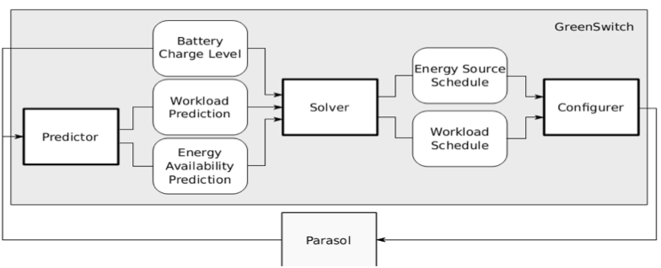

Above figure indicates the GreenSwitch components.

**Predictor:** This component predicts the workloads and the renewable energy production.

**Solver:** This component takes the prediction and the current battery charge level from predictor as an input, and outputs a workload schedule and an energy source schedule.

**Configurer:** It effects the changes prescribed by the solver, and it is the only part specific to the system GreenSwitch is supposed to control.

## Models, Optimization, and Solution Approach

In this part, we formulate the optimization problems that the solver implements, and discuss how it instantiates and solves them.

**Modeling energy sources:**

There are three sources to power the house which are Battery, solar energy and grid.

For modeling bettery, we assume total battery charge rate cannot be higher than BattCapa/4,

$BattGreen\left(t\right)+BattGrid(t)≤BattCapa/4$

Power discharged from the battery is never greater than the power charged to the battery:

$\sum{LoadBatt\left(t\right)}-BattE ×\sum{\left(BattGreen\left(t\right)+BattGrid\left(t\right)\right)≤0}$

The energy stored in battery, which is the difference between the energy charged to or discharged from the battery over the previous time intervals, cannot be greater than its capacity:

$\sum{BattGreen\left(t\right)+ \sum{BattGrid\left(t\right)-\left(\frac{1}{BattE}\right)* \sum{LoadBatt(t)≤}}}BattCapa$

The renewable power, Green(t), may be used to run the LoadGreen(t), to charge the battery(BattGreen(t)), and/or ner metering (NetGreen(t)):

$LoadGreen\left(t\right)+BattGreen\left(t\right)+NetGreen\left(t\right)≤Green(t)$

We cannot use the batteries and do net metering at the same time given $LoadBatt\left(t\right)>0$, $NetGreen\left(t\right)=0$ or vice versa:

$LoadBatt\left(t\right)-∞*bin(t)≤0$

$-∞*LoadBatt\left(t\right)+bin\left(t\right)≤0$

$NetGreen\left(t\right)+∞*bin(t)≤∞$

We cannot draw from the grid to power the load at the same time as doing net metering

Given $LoadGrid\left(t\right)≥0,NetGreen\left(t\right)=0$ or vice versa

$LoadGrid\left(t\right)-∞*bin(t)≤0$

$-∞*LoadGrid\left(t\right)+bin\left(t\right)≤0$

$NetGreen\left(t\right)+∞*bin(t)≤∞$

We cannot charge and discharge the battery at the same time

Given $LoadBatt\left(t\right)>0,BattGreen\left(t\right)+BattGrid\left(t\right)=0$ or vice versa

$LoadBatt\left(t\right)-∞*bin\left(t\right)≤0$

$-∞*LoadBatt\left(t\right)+bin\left(t\right)≤0$

$BattGreen\left(t\right)+BattGrid\left(t\right)+∞*bin(t)≤∞$

**Modeling workloads:**

$LoadBatt\left(t\right)+LoadGrid\left(t\right)+LoadGreen\left(t\right)=nonDeferLoad\left(t\right)+preemptibleLoads(t)$

The grid can be used to power the load and charge the battery:

$LoadGrid\left(t\right)+BattGrid\left(t\right)-Grid\left(t\right)=0$

preemptibleLoads scheduling:

For each cycle(T/period),

$\sum{ preemptibleLoads\left(t\right)=power per peroid }$

The grid can be used to power the load and charge the battery:

$LoadGrid\left(t\right)+BattGrid\left(t\right)-Grid\left(t\right)=0$

preemptibleLoads scheduling:

For each cycle(T/period),

$\sum{ preemptibleLoads\left(t\right)=power per peroid }$

**Optimization Goals**

Our model goal is achieving minimum electricity goal, the objective function is as follows:

$Total electricity cost m=\sum{(GridCost\left(t\right)*Grid\left(t\right)-α*GridCost\left(t\right)*NetGreen\left(t\right))}$

# Experimental Evaluation

## Methodology

In order to quantify the potential for saving based on the electricity market pricing plans, we need data about the home house electricity consumption. Additionally, the environmental data provided by the weather sensors can be used to predict the aggregate consumption for homes.

Researchers from UMASS Amherst computer science department made publicly available numerous data sets in the paper ”Cutting the Electricity Bill in Smart Homes with Energy Storage”. Professor Irwin is one of its authors. So he provided us the required data sets. The data sets include three homes’ electricity consuming value during the period between April and July in 2012.

Take the data observed from home A for example. Home A is located around Amherst. The data sets collected the energy consumption of home A for 68 days. For each day, dataset came from 26 indexed different sources, including grid, HRV, washing machine, bedroom lights and so on. We filtered only the average real and apparent powers every second from grid supply which represents the aggregate consumption per second for the whole home house. Every day has 86 thousands and 4 hundreds seconds but the amount of the filtered data is less than this amount. In addition, the timestamp for each data is unix time which means that how many seconds have passed since January 1st 1970 however we found that the timestamps are not correct. So we used MATLAB to process the filtered data by inserting data into those lost seconds as same as the last reasonable value and shifting all data to correct starting place for every day according to the timestamps. Finally, we calculated interval power (power per hour), day power and month power.

And then we collected the outdoor temperature and outdoor humidity for every day from the website www.wunderground .com which contains the history weather data collected from the sensor that is located in UMASS Amherst computer science building. Also we labeled weekday as “0” and weekend or holiday as “1” that can be convenient for future process as data input.

The following figure is part of the final results after the processes mentioned above:

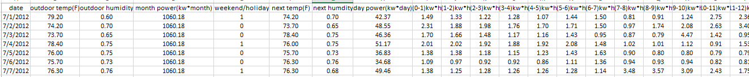

## Experimental Results

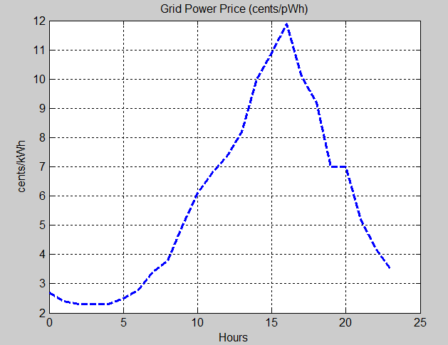We need to do some assumptions at first. First, the battery is not empty at the beginning of every day. Second, we assume that we can behave like an oracle, in other words, we can know that day’s power pattern and solar availability during that day. Third, the period is integer and it can be divided by the execution time T. Forth, the deadline is equal to period.

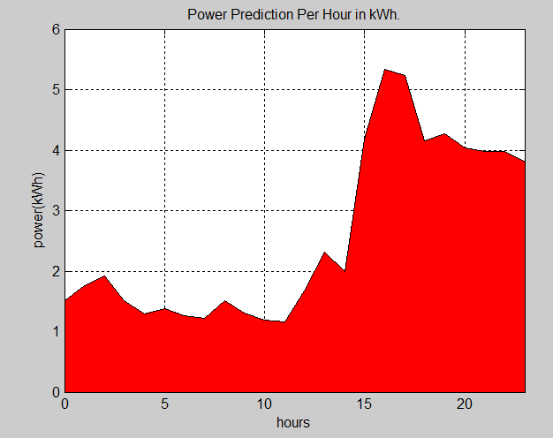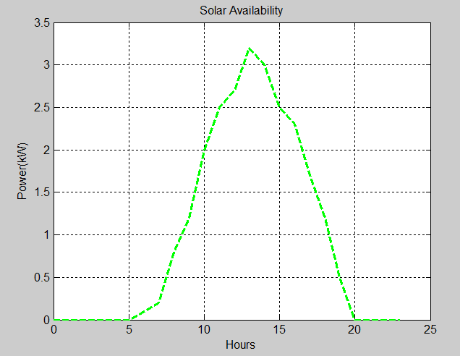

These are the data fundation for the testing and simulation. We choose one day’s data form the data sets. The first one is the power pattern per hour for the whole day. The second one is the solar prediction for that day. In common sence, solar strength during the 12pm and 2 pm is the highest. The third figure plots the electricity grid price per hour for each day according to the electricity market pricing plans which are fixed. Additionally, we choose three appliances in house for deferrable modeling, including Central Air Conditioner, refrigerator and dishwasher. Among them, dishwasher is not pre-emptible. The parameter for each appliance is as following:

ACCentral = [24,24,8,56]

Refrigerator = [2,2,1,0.36]

Dishwasher = [24,24,2,4]

Note [deadine, period, execution time, power per cycle]

**Battery Only Scheculing Simulation:**

This the simulation result for the battery only scheduling which means that we just use battery and grid supply to power the whole home house. The area below the black line is the power demand which has been plotted in the data fundation. The red area is the grid power consumption. From this figure, we can see that, during 0 am and 5am which is the low-cost period based on the grid power pricing plan, we use some grid power to supply for the power demand, the extra grid power is used to charge the battery which will be in turn used during the high-cost period that is blue area in this figure. Under this scheduling, the electricity bill is $2.3 with the battery only , compared with the $4.17 which is the original electricity bill without using the battery. The total cost reduction is up to 44%.

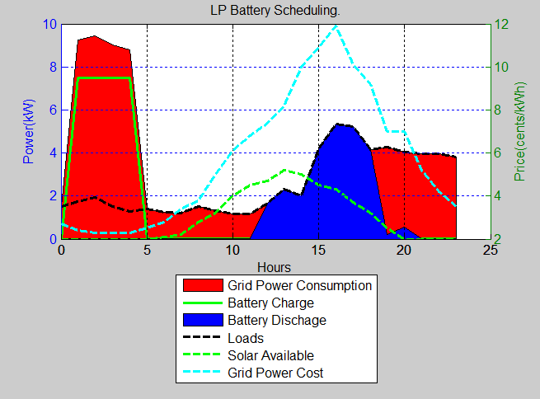

**Battery Solar Scheduling Simulation:**

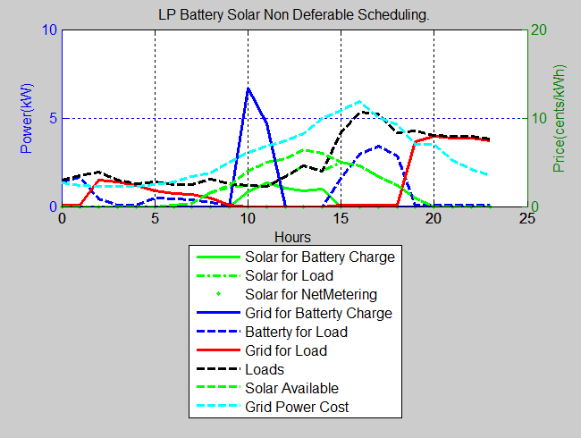

In this simulation, we add the solar to the previous power supply group which includes the grid and battery. Compared with the last figure, because we know that in that day, we can use solar availability, we do not need to charge the battery a lot during the night. Instead we use solar to charge the battary during the day when the solar is available. When the peak power demand is coming, the solar and battery both supply electricity power. The resulting electricity bill under this scheduling is $1.98 which is reduced by 52%.

**Battery Solar Plus Workload Scheduling Simulation:**

Other than battery and solar for supplying, we use the deferrable modeling to schedule the workload as well. From the diagram, the black line which respresents the workload is changed by shifting the deferrable workload to the low-cost period so that getting the bill reduction. This scheduling can save the most which is 54%.

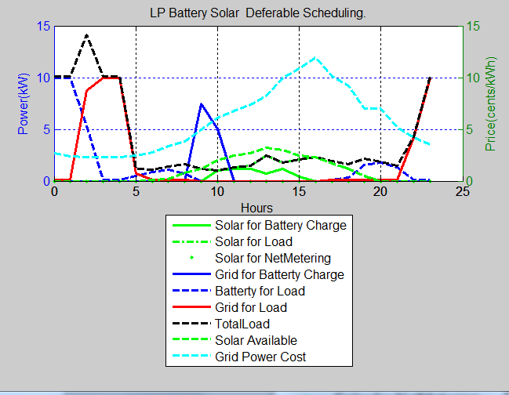

# Future Work

# Conclusion

# References

1. Íñigo Goiri, William Katsak, Kien Le, Thu D. Nguyen, and Ricardo Bianchini. [Parasol and GreenSwitch: Managing Datacenters Powered by Renewable Energy](http://www.cs.rutgers.edu/~ricardob/papers/asplos13.pdf). [ASPLOS 2013](http://asplos13.rice.edu/)
2. Sean Barker, Aditya Mishra, David Irwin, Emmanuel Cecchet, Prashant Shenoy, and Jeannie Albrecht. Smart*: An Open Data Set and Tools for Enabling Research in Sustainable Homes. Proceedings of the 2012 Workshop on Data Mining Applications in Sustainability (SustKDD 2012), Beijing, China, August 2012.
3. DOE. Buildings Energy Data Book, Department of Energy, March 2009. <http://buildingsdatabook.eren.doe.gov>
4. Y. Agarwal, B. Balaji, R. Gupta, J. Lyles, M. Wei, and T. Weng. Occupancy-Driven Energy Management for Smart Building Automation. In Second ACM Workshop on Embedded Sensing Systems For Energy-Efficiency In Buildings, 2010
5. Y. Agarwal, T. Weng, and R. Gupta. The Energy Dashboard: Improving the Visibility of Energy Consumption at a Campus-Wide Scale. In First ACM Workshop on Embedded Sensing Systems For Energy-Efficiency In Buildings, 2009
6. Data Center Knowledge. Apple Plans 20MW of Solar Power for iDataCenter, 2012. <http://www.datacenterknowledge.com/archives/2012/02/20/apple-plans-20mw-of-solar-power-for-idatacenter>
7. Data Center Knowledge. Data Centers Scale Up Their Solar Power,2012, http://www.datacenterknowledge.com/archives/2012/05/14/data-centers-scale-up-their-solar-power/